Example: Complete Program: Splitter Control, Tree Control, Picture Control, Events related to Tree Control
REPORT Z930ALV6.
include z930alv6_vardec.
INCLUDE z930alv6_moddef.
include z930alv6_classdef.
INCLUDE z930alv6_subdef.
START-OF-SELECTION.
call screen 100.
Include Program: containing variable declarations (z930alv6_vardec)
data : cust_cont type ref to cl_gui_custom_container,
o_split type ref to cl_gui_splitter_container,
o_tree type ref to cl_gui_simple_tree,
o_pic type ref to cl_gui_picture,
o_cont1 type ref to cl_gui_container,
o_cont2 type ref to cl_gui_container.
data : t_nodes type table of zalvtree,
wa_nodes type zalvtree.
Include Program: containing module definitions (z930alv6_moddef)
MODULE STATUS_0100 OUTPUT.
if cust_cont is not bound.
SET PF-STATUS 'STATUS100'.
* link custom container with custom control
CREATE OBJECT CUST_CONT
EXPORTING
CONTAINER_NAME = 'CUSTCTRL'.
* link splitter control with custom container
CREATE OBJECT O_SPLIT
EXPORTING
PARENT = cust_cont
ROWS = 1
COLUMNS = 2.
* set the widths for columns
CALL METHOD O_SPLIT->SET_COLUMN_WIDTH
EXPORTING
ID = 1
WIDTH = 5.
CALL METHOD O_SPLIT->SET_COLUMN_WIDTH
EXPORTING
ID = 2
WIDTH = 8.
* associate containers for each panes
CALL METHOD O_SPLIT->GET_CONTAINER
EXPORTING
ROW = 1
COLUMN = 1
RECEIVING
CONTAINER = o_cont1.
CALL METHOD O_SPLIT->GET_CONTAINER
EXPORTING
ROW = 1
COLUMN = 2
RECEIVING
CONTAINER = o_cont2.
* picture display logic
perform picture.
* tree logic
perform tree.
endif.
ENDMODULE. " STATUS_0100 OUTPUT
MODULE USER_COMMAND_0100 INPUT.
case sy-ucomm.
when 'BACK'.
leave PROGRAM.
endcase.
ENDMODULE. " USER_COMMAND_0100 INPUT
Include Program: containing class definitions (z930alv6_classdef)
class lcl_eventreceiver DEFINITION.
public SECTION.
methods handle_node_context_menu_req
for event node_context_menu_request
of cl_gui_simple_tree
importing node_key menu.
methods handle_node_context_menu_sel
for event NODE_CONTEXT_MENU_SELECT
of cl_gui_simple_tree
importing fcode.
methods handle_node_double_click
for event node_double_click
of cl_gui_simple_tree
importing node_key.
methods handle_node_keypress
for event node_keypress
of cl_gui_simple_tree
IMPORTING node_key key.
endclass.
class lcl_eventreceiver IMPLEMENTATION.
method handle_node_context_menu_req.
* message 'context menu request' type 'I'.
case node_key.
when 'RT'.
CALL METHOD MENU->ADD_FUNCTION
EXPORTING
FCODE = 'MI1'
TEXT = 'Sales Orders'.
CALL METHOD MENU->ADD_FUNCTION
EXPORTING
FCODE = 'MI2'
TEXT = 'Purchase Orders'.
when 'SO'.
CALL METHOD MENU->ADD_FUNCTION
EXPORTING
FCODE = 'MI3'
TEXT = 'Create Sales Order'.
CALL METHOD MENU->ADD_FUNCTION
EXPORTING
FCODE = 'MI4'
TEXT = 'Change Sales Order'.
CALL METHOD MENU->ADD_FUNCTION
EXPORTING
FCODE = 'MI5'
TEXT = 'Display Sales Order'.
when 'PO'.
CALL METHOD MENU->ADD_FUNCTION
EXPORTING
FCODE = 'MI6'
TEXT = 'Create Purchase Order'.
CALL METHOD MENU->ADD_FUNCTION
EXPORTING
FCODE = 'MI7'
TEXT = 'Change Purchase Order'.
CALL METHOD MENU->ADD_FUNCTION
EXPORTING
FCODE = 'MI8'
TEXT = 'Display PurchaseOrder'.
endcase.
endmethod.
method handle_node_context_menu_sel.
if fcode = 'MI1'.
CALL METHOD O_TREE->SET_SELECTED_NODE
EXPORTING
NODE_KEY = 'SO'.
elseif fcode = 'MI2'.
CALL METHOD O_TREE->SET_SELECTED_NODE
EXPORTING
NODE_KEY = 'PO'.
elseif fcode = 'MI3'.
call transaction 'VA01'.
elseif fcode = 'MI4'.
call transaction 'VA02'.
elseif fcode = 'MI5'.
call transaction 'VA03'.
elseif fcode = 'MI6'.
call transaction 'ME21'.
elseif fcode = 'MI7'.
call transaction 'ME22'.
elseif fcode = 'MI8'.
call transaction 'ME23'.
endif.
endmethod.
method handle_node_double_click.
case node_key.
when 'CSO'.
call transaction 'VA01'.
when 'CHSO'.
call transaction 'VA02'.
when 'DSO'.
call transaction 'VA03'.
when 'CPO'.
call transaction 'ME21'.
when 'CHPO'.
call transaction 'ME22'.
when 'DPO'.
call transaction 'ME23'.
endcase.
endmethod.
method handle_node_keypress.
case node_key.
when 'RT'.
if key = cl_gui_simple_tree=>key_enter.
CALL METHOD O_TREE->EXPAND_NODE
EXPORTING
NODE_KEY = 'RT'.
endif.
when 'DSO'.
if key = cl_gui_simple_tree=>key_enter.
call transaction 'VA03'.
elseif key = cl_gui_simple_tree=>key_delete.
CALL METHOD O_TREE->DELETE_NODE
EXPORTING
NODE_KEY = 'DSO'.
elseif key = cl_gui_simple_tree=>key_f1.
CALL FUNCTION 'POPUP_TO_INFORM'
EXPORTING
TITEL = 'Display Sales Order'
TXT1 = 'CALLS T-code VA03'
TXT2 = 'Child node of Sales order'.
endif.
endcase.
endmethod.
endclass.
Include Program: containing subroutine definitions (z930alv6_subdef)
FORM PICTURE .
*link picture control with container o_cont2
CREATE OBJECT O_PIC
EXPORTING
PARENT = o_cont2.
* get the URL of the picture
data pic_url type cndp_url.
CALL FUNCTION 'DP_PUBLISH_WWW_URL'
EXPORTING
OBJID = 'ZFLY' "image object id
LIFETIME = cndp_lifetime_transaction
IMPORTING
URL = pic_url.
* display the picture in the container
CALL METHOD O_PIC->LOAD_PICTURE_FROM_URL
EXPORTING
URL = pic_url.
* set the display mode
CALL METHOD O_PIC->SET_DISPLAY_MODE
EXPORTING
DISPLAY_MODE = cl_gui_picture=>DISPLAY_MODE_FIT_CENTER.
ENDFORM. " PICTURE
FORM TREE .
* link tree control with container o_cont1
CREATE OBJECT O_TREE
EXPORTING
PARENT = o_cont1
NODE_SELECTION_MODE = cl_gui_simple_tree=>NODE_SEL_MODE_SINGLE.
* prepare nodes info
perform preparenodes.
if t_nodes is not initial.
* register handlers for tree control
perform reghandlers.
* display the nodes on to the tree control
CALL METHOD O_TREE->ADD_NODES
EXPORTING
TABLE_STRUCTURE_NAME = 'ZALVTREE'
NODE_TABLE = t_nodes.
endif.
ENDFORM. " TREE
FORM PREPARENODES .
clear wa_nodes.
wa_nodes-node_key = 'RT'.
wa_nodes-isfolder = 'X'.
wa_nodes-expander = 'X'.
wa_nodes-text = 'Transactions'.
append wa_nodes to t_nodes.
clear wa_nodes.
wa_nodes-node_key = 'SO'.
wa_nodes-relatkey = 'RT'.
wa_nodes-isfolder = 'X'.
wa_nodes-expander = 'X'.
wa_nodes-text = 'Sales Orders'.
append wa_nodes to t_nodes.
clear wa_nodes.
wa_nodes-node_key = 'CSO'.
wa_nodes-relatkey = 'SO'.
wa_nodes-n_image = '@15@'.
wa_nodes-text = 'Create Sales Order'.
append wa_nodes to t_nodes.
clear wa_nodes.
wa_nodes-node_key = 'CHSO'.
wa_nodes-relatkey = 'SO'.
wa_nodes-n_image = '@15@'.
wa_nodes-text = 'Change Sales Order'.
append wa_nodes to t_nodes.
clear wa_nodes.
wa_nodes-node_key = 'DSO'.
wa_nodes-relatkey = 'SO'.
wa_nodes-n_image = '@15@'.
wa_nodes-text = 'Display Sales Order'.
append wa_nodes to t_nodes.
clear wa_nodes.
wa_nodes-node_key = 'PO'.
wa_nodes-relatkey = 'RT'.
wa_nodes-isfolder = 'X'.
wa_nodes-expander = 'X'.
wa_nodes-text = 'Purchase Orders'.
append wa_nodes to t_nodes.
clear wa_nodes.
wa_nodes-node_key = 'CPO'.
wa_nodes-relatkey = 'PO'.
wa_nodes-n_image = '@15@'.
wa_nodes-text = 'Create Purchase Order'.
append wa_nodes to t_nodes.
clear wa_nodes.
wa_nodes-node_key = 'CHPO'.
wa_nodes-relatkey = 'PO'.
wa_nodes-n_image = '@15@'.
wa_nodes-text = 'Change Purchase Order'.
append wa_nodes to t_nodes.
clear wa_nodes.
wa_nodes-node_key = 'DPO'.
wa_nodes-relatkey = 'PO'.
wa_nodes-n_image = '@15@'.
wa_nodes-text = 'Display Purchase Order'.
append wa_nodes to t_nodes.
ENDFORM. " PREPARENODES
FORM REGHANDLERS .
data ob type ref to lcl_eventreceiver.
create object ob.
set handler ob->handle_node_context_menu_req for o_tree.
set handler ob->handle_node_context_menu_sel for o_tree.
set handler ob->handle_node_double_click for o_tree.
set handler ob->handle_node_keypress for o_tree.
data : t_events type CNTL_SIMPLE_EVENTS,
wa_event like line of t_events.
* register the event node_context_menu_request explictly
clear wa_event.
wa_event-eventid = cl_gui_simple_tree=>EVENTID_NODE_CONTEXT_MENU_REQ.
append wa_event to t_events.
* register the event node_double_click explictly
clear wa_event.
wa_event-eventid = cl_gui_simple_tree=>EVENTID_NODE_DOUBLE_CLICK.
append wa_event to t_events.
* register the event node_keypress explictly
clear wa_event.
wa_event-eventid = cl_gui_simple_tree=>EVENTID_NODE_KEYPRESS.
append wa_event to t_events.
CALL METHOD O_TREE->SET_REGISTERED_EVENTS
EXPORTING
EVENTS = t_events.
* register keyboard keys for triggering node_keypress event
CALL METHOD O_TREE->ADD_KEY_STROKE
EXPORTING
KEY = cl_gui_simple_tree=>key_f1.
CALL METHOD O_TREE->ADD_KEY_STROKE
EXPORTING
KEY = cl_gui_simple_tree=>key_delete.
CALL METHOD O_TREE->ADD_KEY_STROKE
EXPORTING
KEY = cl_gui_simple_tree=>key_enter.
ENDFORM. " REGHANDLERS
Flow logic of screen 100:
PROCESS BEFORE OUTPUT.
MODULE STATUS_0100.
*
PROCESS AFTER INPUT.
MODULE USER_COMMAND_0100.
Layout of Screen 100:
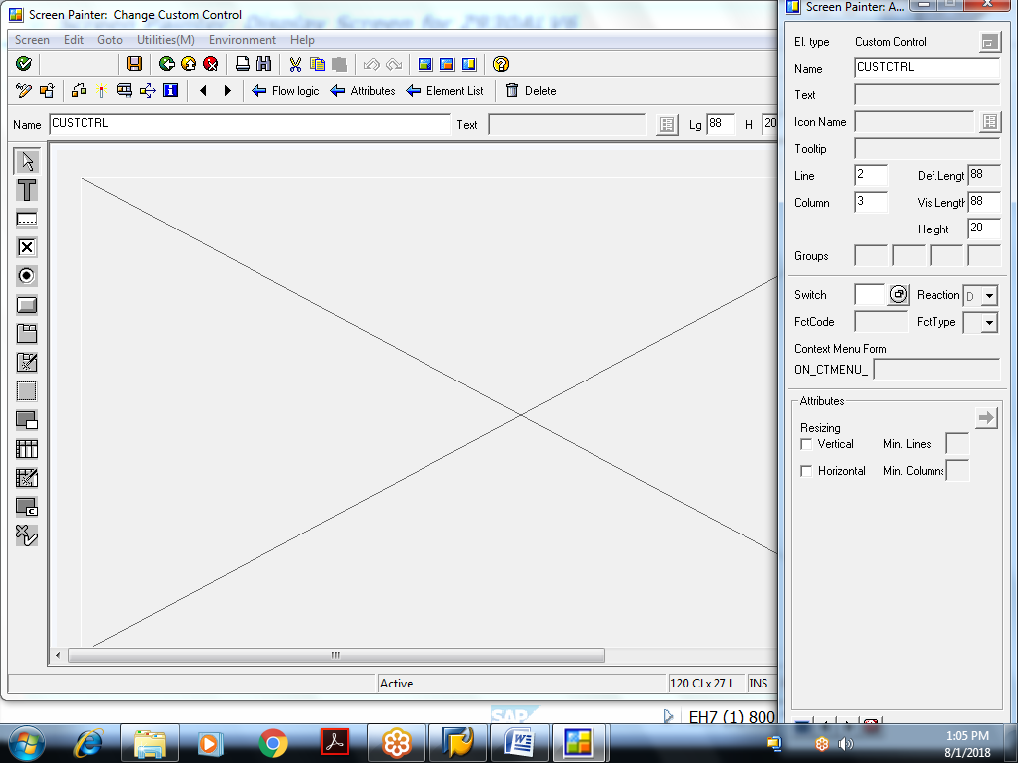

Example: ALV Cell coloring, ALV Traffic light column, ALV Drop down column
REPORT Z930ALV7.
include z930alv7_vardec.
INCLUDE z930alv7_moddef.
INCLUDE z930alv7_subdef.
start-of-SELECTION.
call screen 100.
Include Program: containing variable declarations (z930alv6_vardec)
data v_vbeln type vbak-vbeln.
SELECT-OPTIONS so_vbeln for v_vbeln DEFAULT '4980' to '5030'.
data : vbak_cont type ref to cl_gui_custom_container,
vbak_grid type ref to cl_gui_alv_grid.
data : t_fcat type lvc_t_fcat,
wa_fcat type lvc_s_fcat.
data wa_layo type lvc_s_layo.
types : begin of ty_vbak.
include type zcvbak.
types : netwr type vbak-netwr,
end of ty_vbak.
data : t_vbak type table of ty_vbak,
wa_vbak type ty_vbak.
types : begin of ty_final_vbak.
include type zcvbak.
types : netwr type vbak-netwr,
cellcolor type lvc_t_scol,
lights type c,
ordertype type string,
end of ty_final_vbak.
data : t_final_vbak type table of ty_final_vbak,
wa_final_vbak type ty_final_vbak.
data wa_cellcolor type lvc_s_scol.
Include Program: containing module definitions(Z930ALV7_MODDEF)
MODULE STATUS_0100 OUTPUT.
if vbak_cont is not bound.
SET PF-STATUS 'STATUS100'.
* link container with custom control
CREATE OBJECT VBAK_CONT
EXPORTING
CONTAINER_NAME = 'CUSTCTRL'.
* link alv grid with custom container
CREATE OBJECT VBAK_GRID
EXPORTING
I_PARENT = vbak_cont.
* get sales orders
perform getvbak.
if t_vbak is not INITIAL.
* generate field catalog for sales orders grid
perform fldcatvbak.
* generate layout
perform layoutvbak.
* prepare dropdown column values
perform dropdown_ordertype.
* display sales orders
perform displayvbak.
endif.
endif.
ENDMODULE. " STATUS_0100 OUTPUT
MODULE USER_COMMAND_0100 INPUT.
case sy-ucomm.
when 'BACK'.
leave program.
endcase.
ENDMODULE. " USER_COMMAND_0100 INPUT
Include Program: containing subroutine definitions (Z930ALV7_MODDEF)
FORM GETVBAK .
select vbeln erdat erzet ernam netwr
from vbak
into table t_vbak
where vbeln in so_vbeln.
if sy-subrc eq 0.
clear wa_vbak.
loop at t_vbak into wa_vbak.
clear wa_final_vbak.
clear wa_cellcolor.
MOVE-CORRESPONDING wa_vbak to wa_final_vbak.
if wa_vbak-netwr < 10000.
wa_final_vbak-lights = '1'. "red
wa_cellcolor-fname = 'VBELN'.
wa_cellcolor-color-col = 5.
wa_cellcolor-color-int = 1.
wa_cellcolor-color-inv = 0.
append wa_cellcolor to wa_final_vbak-cellcolor.
elseif wa_vbak-netwr >= 10000 and wa_vbak-netwr < 40000.
wa_final_vbak-lights = '2'. "orange
wa_cellcolor-fname = 'VBELN'.
wa_cellcolor-color-col = 7.
wa_cellcolor-color-int = 1.
wa_cellcolor-color-inv = 0.
append wa_cellcolor to wa_final_vbak-cellcolor.
else.
wa_final_vbak-lights = '3'. "green
wa_cellcolor-fname = 'VBELN'.
wa_cellcolor-color-col = 3.
wa_cellcolor-color-int = 1.
wa_cellcolor-color-inv = 0.
append wa_cellcolor to wa_final_vbak-cellcolor.
endif.
append wa_final_vbak to t_final_vbak.
clear wa_vbak.
endloop.
endif.
ENDFORM. " GETVBAK
FORM FLDCATVBAK .
refresh t_fcat.
clear wa_fcat.
wa_fcat-fieldname = 'VBELN'.
wa_fcat-col_pos = 1.
wa_fcat-coltext = 'Sales Doc'.
wa_fcat-outputlen = 12.
append wa_fcat to t_fcat.
clear wa_fcat.
wa_fcat-fieldname = 'ERDAT'.
wa_fcat-col_pos = 2.
wa_fcat-coltext = 'Creation Date'.
wa_fcat-outputlen = 12.
append wa_fcat to t_fcat.
clear wa_fcat.
wa_fcat-fieldname = 'ERDAT'.
wa_fcat-col_pos = 3.
wa_fcat-coltext = 'Creation Time'.
wa_fcat-outputlen = 12.
append wa_fcat to t_fcat.
clear wa_fcat.
wa_fcat-fieldname = 'ERNAM'.
wa_fcat-col_pos = 4.
wa_fcat-coltext = 'Created By'.
wa_fcat-outputlen = 12.
append wa_fcat to t_fcat.
clear wa_fcat.
wa_fcat-fieldname = 'NETWR'.
wa_fcat-col_pos = 5.
wa_fcat-coltext = 'Net Value'.
wa_fcat-outputlen = 12.
append wa_fcat to t_fcat.
clear wa_fcat.
wa_fcat-fieldname = 'LIGHTS'.
wa_fcat-col_pos = 6.
wa_fcat-coltext = 'Status'.
wa_fcat-outputlen = 8.
append wa_fcat to t_fcat.
clear wa_fcat.
wa_fcat-fieldname = 'ORDERTYPE'.
wa_fcat-col_pos = 7.
wa_fcat-coltext = 'Order Type'.
wa_fcat-outputlen = 12.
wa_fcat-drdn_hndl = 50.
wa_fcat-edit = 'X'.
append wa_fcat to t_fcat.
ENDFORM. " FLDCATVBAK
FORM LAYOUTVBAK .
clear wa_layo.
wa_layo-grid_title = 'Sales Orders'.
wa_layo-ctab_fname = 'CELLCOLOR'. "for cell coloring
wa_layo-excp_fname = 'LIGHTS'. "for traffic lights
ENDFORM. " LAYOUTVBAK
FORM DISPLAYVBAK .
CALL METHOD VBAK_GRID->SET_TABLE_FOR_FIRST_DISPLAY
EXPORTING
IS_LAYOUT = wa_layo
CHANGING
IT_OUTTAB = t_final_vbak
IT_FIELDCATALOG = t_fcat.
ENDFORM. " DISPLAYVBAK
FORM DROPDOWN_ORDERTYPE .
data : t_drop type lvc_t_drop,
wa_drop type lvc_s_drop.
clear wa_drop.
wa_drop-handle = 50.
wa_drop-value = 'High order'.
append wa_drop to t_drop.
clear wa_drop.
wa_drop-handle = 50.
wa_drop-value = 'Medium order'.
append wa_drop to t_drop.
clear wa_drop.
wa_drop-handle = 50.
wa_drop-value = 'Low order'.
append wa_drop to t_drop.
CALL METHOD VBAK_GRID->SET_DROP_DOWN_TABLE
EXPORTING
IT_DROP_DOWN = t_drop.
ENDFORM. " DROPDOWN_ORDERTYPE
Flow logic of screen 100:
PROCESS BEFORE OUTPUT.
MODULE STATUS_0100.
*
PROCESS AFTER INPUT.
MODULE USER_COMMAND_0100.

Layout of screen 100:
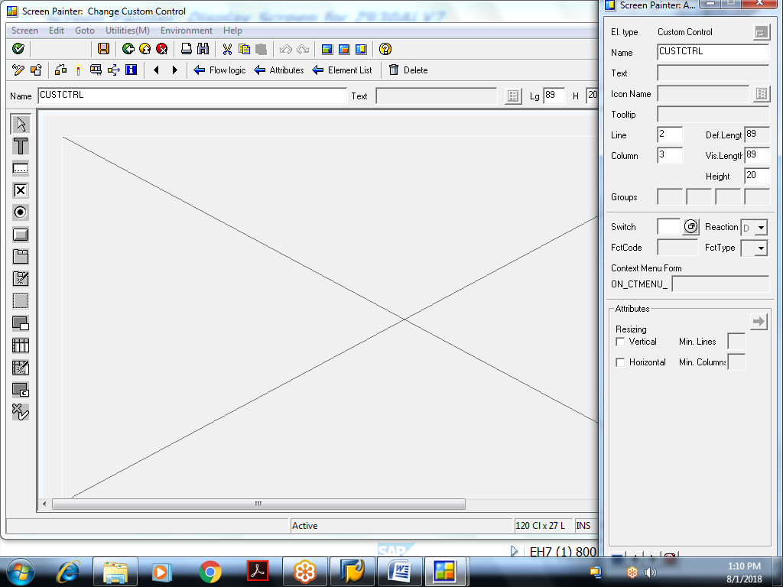
GUI status of screen 100:
